Working with Jupyter Labs

The Jupyter Notebook is an open-source web application used to create and share documents containing live code, equations, visualizations, and text. We will be using pre-installed containers with jupyter. The Jupyter Notebook App is a server-client application that allows editing and running notebook documents via a web browser. PARAM Siddhi-AI system allows users to access the Jupyter notebook on their local system while setting up and running on the PARAM Siddhi- AI cluster.

To access the labs follow the below steps:

1. Log into PARAM Siddhi-AI system
2. Copy the Lab submission script and other files required from lab to home directory (One time only)

***cp -r /raid/gpucbh/* ~***

1. Check if you have any existing jobs running on the cluster

***squeue -u$USER***

1. If there are no jobs running in the cluster submit the job by using the script just copied

***sbatch day1_batch <port_no>***

Where port_no is the port assigned to you by the cluster admin. Please check the slack channel for the port number assigned to you. Port number can also be verified from the access details e-mail sent on 28th March.

In case job is already running, you can cancel the same using following command :

***scancel <job_id>***

* + Where job_id is the job id you get from squeue command mentioned above
  + **Please note every user can submit max one job at a time.**

1. Check if the job is successfully submitted

***squeue -u$USER***

1. Create the tunnel
   1. The tunnel information is by default created in the ***port_fowarding_command*** file
   2. Use the information of file to open a port tunnel using one of the methods given below.

***cat port_forwarding_command***

Follow steps as given on the “Tunneling Section” on next page. Once it is done, then,

1. Open Browser and type

***localhost:<port_no>***

Where port_no is the port assigned to you and mentioned in step IV

* In case you want to cancel existing job you can use the following command:

***scancel job_id***

* + Where job_id is the job id you get from squeue command mentioned above
  + Please note every user can submit max one job at a time.

Tunneling for Linux or Mac User

* Step 1: Copy paste the command part of the **port_fowarding_command** file generated in step VI above. For example

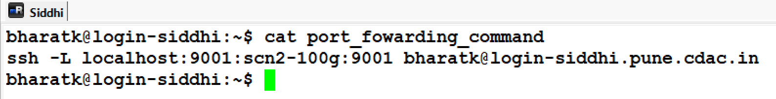

In case of having local linux system, you can directly copy paste the command in separate terminal of your local machine and enter the password and you can directly open browser and type localhost:<port no>, after you have entered password for your login on siddhi.

i.e.

* Step 2: In a new terminal copy paste the cpmmand and login.
* Step 3: open local browser and type localhost:<port_no>

Tunneling for Windows Users using putty

* Step 1: Provide the username with Param Siddhi login server

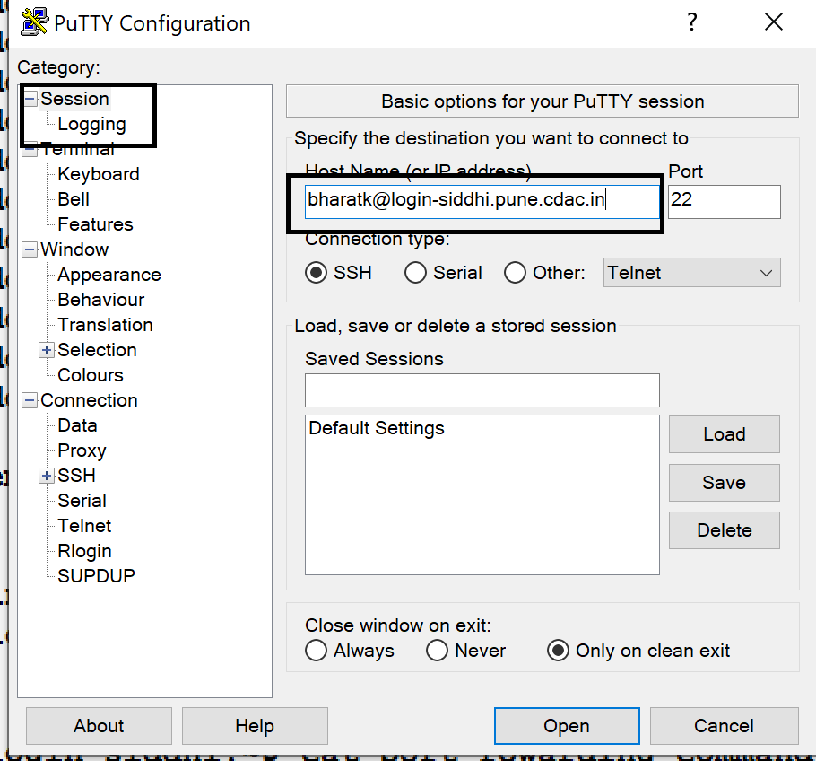

Step 2: Provide the tunnel info and connect as per the port_fowading_command.

For example if the file text is :

ssh -L localhost:9001:scn2-100g:9001 [bharatk@login-siddhi.pune.cdac.in](mailto:bharatk@login-siddhi.pune.cdac.in)

* 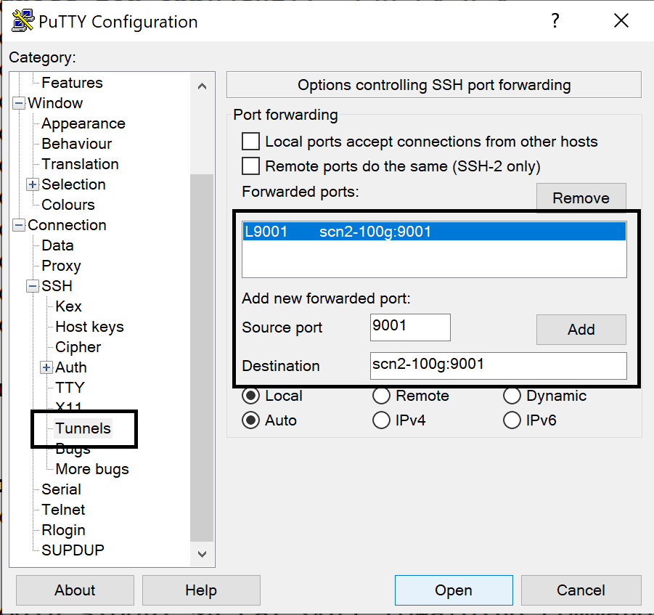
* Step 3: open local browser and type localhost:<port_no>

Tunneling for Windows Users MobaXterm

**Accessing the PARAM Siddhi-AI Compute Node is a 2-stage process:**

**Stage-1: Tunnel creation using MobaXterm**

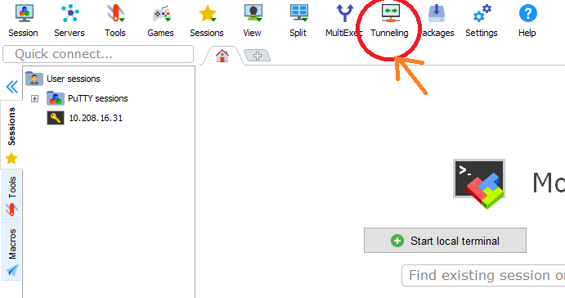

Open MobaXterm software click on Tunneling Options

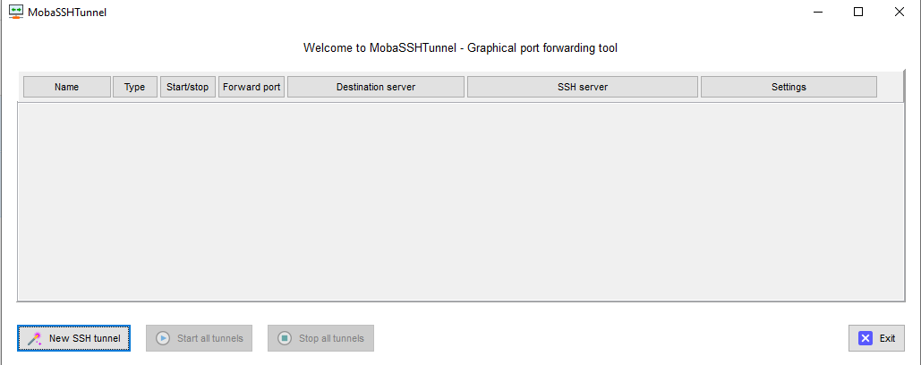

It’s open MobaSSHTunnel Graphical Port forwarding Tool Wizard

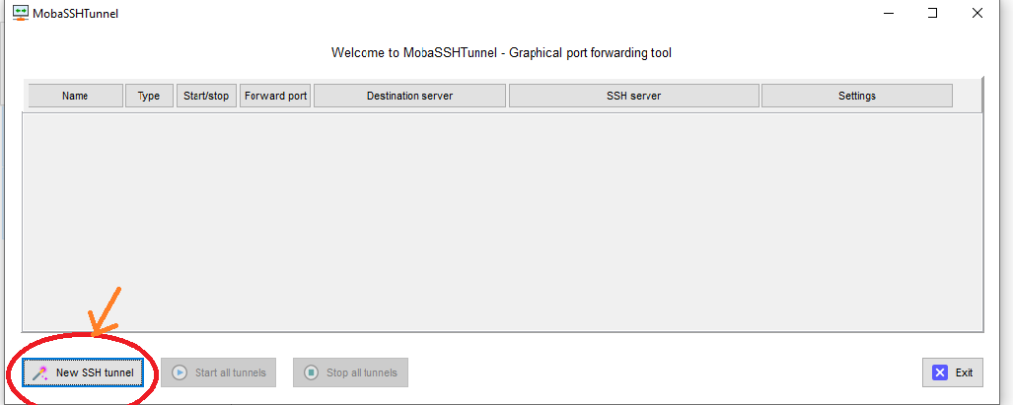

Click on New SSH Tunnel Option

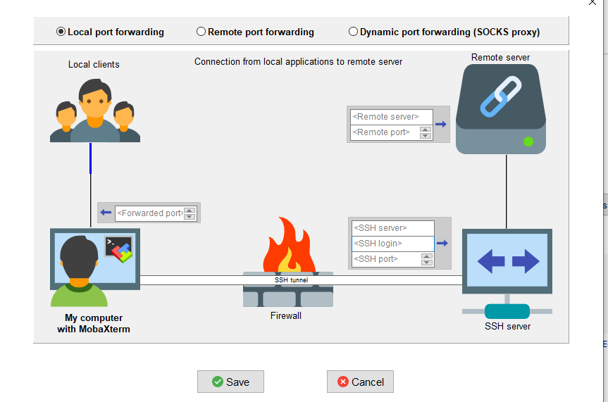

Its open Local port forwarding wizard

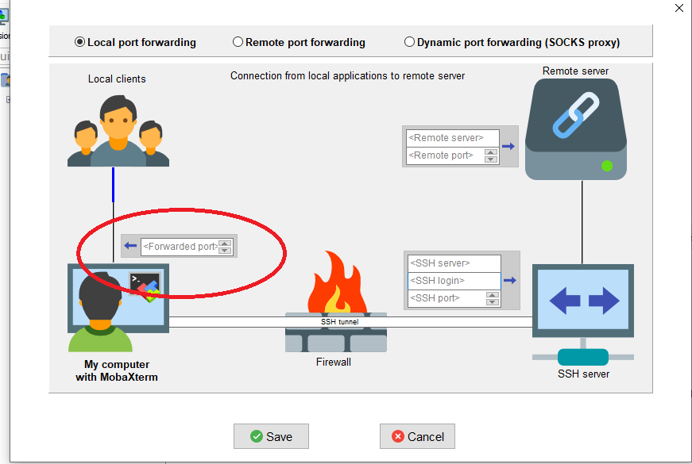

Enter Local ( Laptop or Desktop ) forward port number

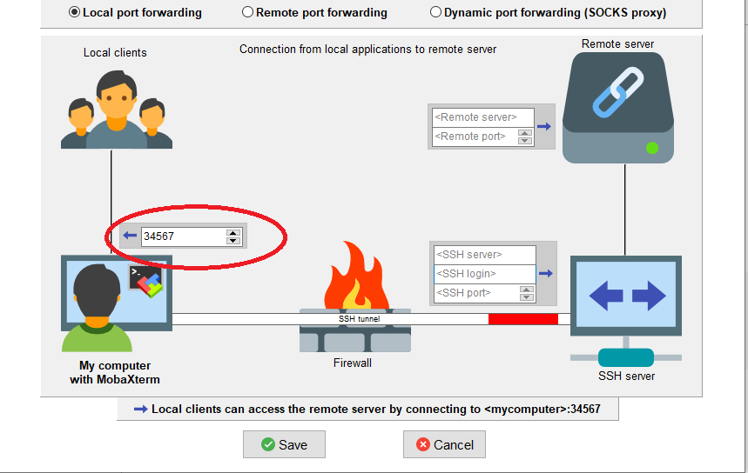

**Note**: replace with appropriate local forward port number .

One can specify any local port assigned to you

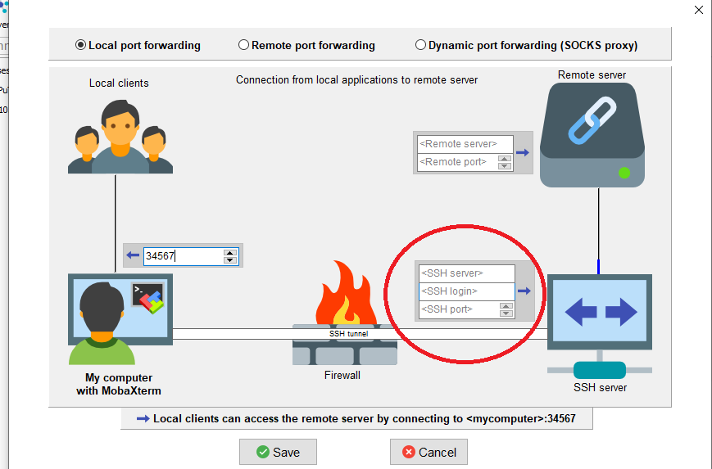

Please Enter Gateway system details

SSH Server: login-siddhi.pune.cdac.in

SSH Login: Your username

SSH port: 22

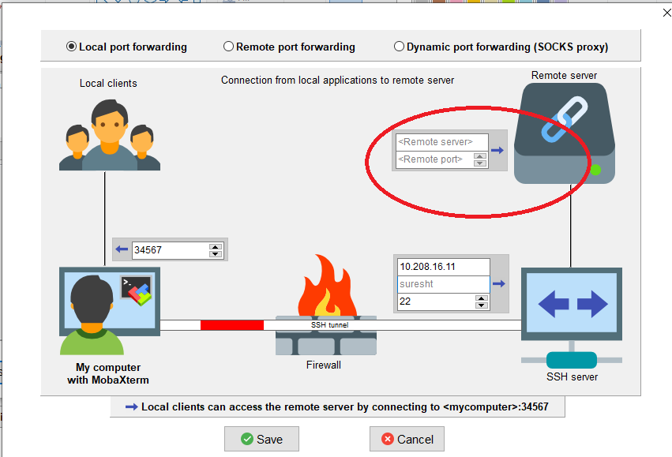

Enter Remote server PARAM Siddhi compute Details provided by the port_forwading_command file

For example if the file text is : ssh -L localhost:9001:scn2-100g:9001 [bharatk@login-siddhi.pune.cdac.in](mailto:bharatk@login-siddhi.pune.cdac.in)

Put remote server as scn2-100g

Put remote port as 9001

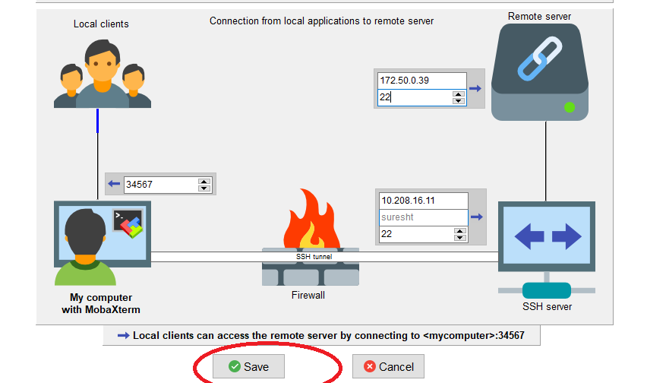

Click on save option

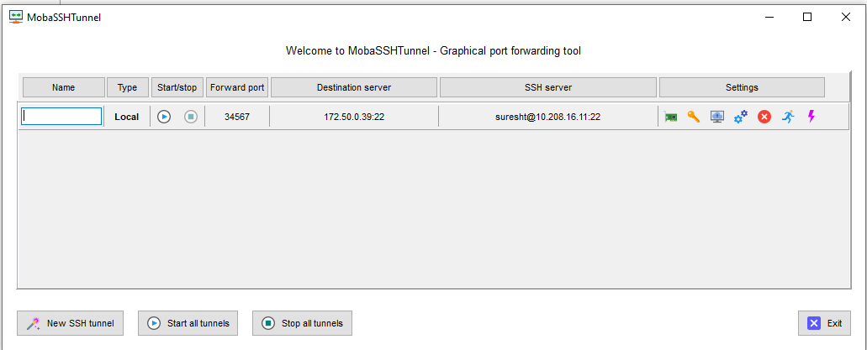

Its Open Tunnel Wizard

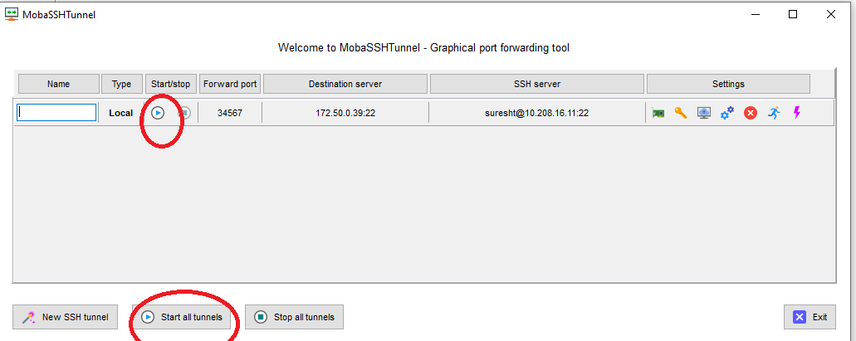

Start Tunnel and Automatically comes Password wizard

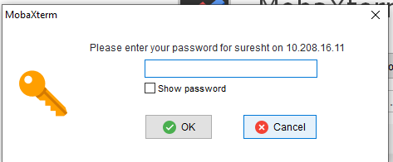

Enter Gateway System password and Enter ok tab